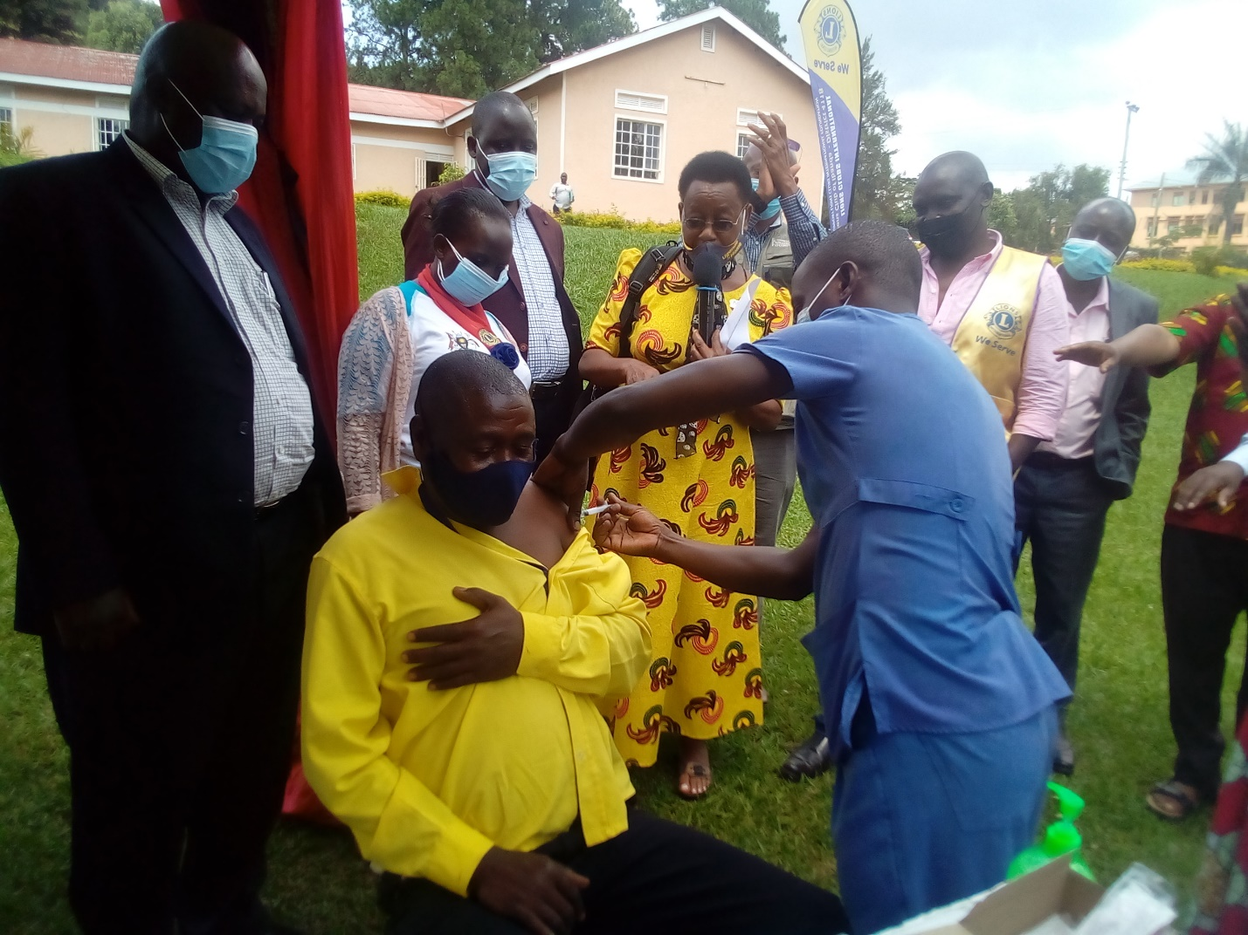
RDC and other District leaders partici[pate at the launch of mass COVID vaccination in Ibanda

